Table of Contents
CHAPTER 1 1
INTRODUCTION 1
1.1 OVERVIEW OF PROJECT 1
1.2 OBJECTIVE 1
1.3 PROBLEM STATEMENT 1
CHAPTER 2 2
LITERATURE SURVEY 2
2.1 RELATED STUDY 2
2.2 PROPOSE SYSTEM 2
CHAPTER 3 3
METHODOLOGY 3
3.1 Data Collection 3
3.2 Data Preprocessing 3
3.3 Model Training using Random Forest classifier 3
CHAPTER-4 5
OUTCOME & CONCLUSION 5
4.1 OUTCOME 5
4.2 CONCLUSION 5
REFERENCE 6

CHAPTER 1

INTRODUCTION

OVERVIEW OF PROJECT
Cryptocurrency are currently gaining popularity and different crypto assets have been introduced into the market. Cryptocurrency is based on Blockchain that promise to revolutionize the monetary system around the world. Even though they are highly volatile, it has become popular due to their features, such as faster money transfers, anonymity, and cheaper transaction costs. Bitcoin and Ethereum may dominate headlines as the giants of the crypto market, but an unexpected challenger has carved out as a light hearted, meme-inspired identity, borrowing from the viral “doge” meme. Dogecoin gained traction, resonating with online communities and amplified by endorsements from celebrities and tech leaders. While global crypto markets are highly correlated, India’s regulations around crypto remain undefined as of now. In the absence of clear and concise laws and regulations for the industry, the future prices of crypto tokens remain harder to predict. This project aims to develop a Dogecoin price movement prediction system using machine learning techniques. The system will utilize historical Dogecoin price data and relevant market indicators to train a machine learning model.

OBJECTIVE
1. Train the dataset to predict whether the price will move up, down over specific time horizon.
2. Identify and engineer the raw data to more valuable format.
3. Create classification model using Random Forest Classifier to predict the price movement.

PROBLEM STATEMENT
After the popularity of Bitcoin, several people brought up it disadvantages. The time of transaction or the whole process of bitcoin consumes a lot of energy. So that some developer considered to make their own alternative coins like Ethereum, Litecoin and Dogecoin. Dogecoin is based on Litecoin, Litecoin has a few advantages over bitcoin like lesser processing time and lower transaction fees. But the market valuation of Dogecoin has already surpassed that of Litecoin. Dogecoin has become the fourth-largest cryptocurrency. Investing in such cryptocurrency is a risk because its price being driven by supply and demand and also community activities play a key role in Dogecoin’s price movement. It is important to note that Investors are required to conduct their research before trading in crypto assets. Investor needs a prediction system that predicts the price movement by analysing historical data.

CHAPTER 2

LITERATURE SURVEY

RELATED STUDY
There have been several studies on using machine learning to predict cryptocurrency prices, including Bitcoin. These studies have employed various machine learning algorithms and data sources to make predictions about future prices. In 2023, Guru Pradeep et al. proposed to identify everyday trends in the Bitcoin market [1]. data set comprises of different elements that have been tracked daily over the course of each year in relation to the Bitcoin price and payment network. To forecast the closing price of the following day, factors including the opening price, highest price, lowest price, closing price, volume of Bitcoin, volume of other currencies, and weighted price were taken into account. Using machine learning random forest model. Another study by Prema Arokia Mary et al. propose a novel hybrid forecasting model that effectively addresses the intricate task of predicting cryptocurrency prices, given their inherent volatility and nonlinear nature [2]. The model integrates Long Short-Term Memory (LSTM) and Transformer architectures to forecast closing values of five prominent cryptocurrencies: Bitcoin (BTC), Ethereum (ETH), Binance Coin (BNB), Tether (USDT), and XRP. Leveraging the strengths of LSTM for capturing long-term dependencies in time series data and the Transformer for identifying crucial elements in input sequences, the hybrid model demonstrates superior prediction accuracy compared to individual LSTM and Transformer models.

PROPOSE SYSTEM
This project approach to predict the dogecoin cryptocurrency price movement based on the historical data of dogecoin OHLC data using Random Forest classifier, Random Forest classifier trained on random subset of the data and combine the forecast of several decision tree resulting in predicting the price movement.

CHAPTER 3

METHODOLOGY

3.1 Data Collection
The dataset contains Dogecoin Historical price data similar to stock market OHLC data. It contains time series index, price data and trading volume.

3.2 Data Preprocessing
To train the dataset to the machine learning model the data need to be clean properly and engineered data to improve the performance some key preprocessing technique include:

Data Exploration and cleaning: Exploring the dataset to identify and understand the data, remove the duplicated entries and handle the missing value.
Data Preparation: Formatting the dataset to better fit the model and improve performance such as converting the data column to datetime and sorting data in chronological order.
Feature Engineering: The raw data open and close could not define the trends. techniques like Selecting, modifying and creating feature such as moving averages, return and volatility to spot the patterns to improve the performance of the model.
  - Model Training using Random Forest classifier
Random Forest is an ensemble learning where ensemble learning mean using multiple base models and combine prediction. In Random Forest multiple decision tree is used and their prediction is combined and take the majority or mean of the value for final prediction.
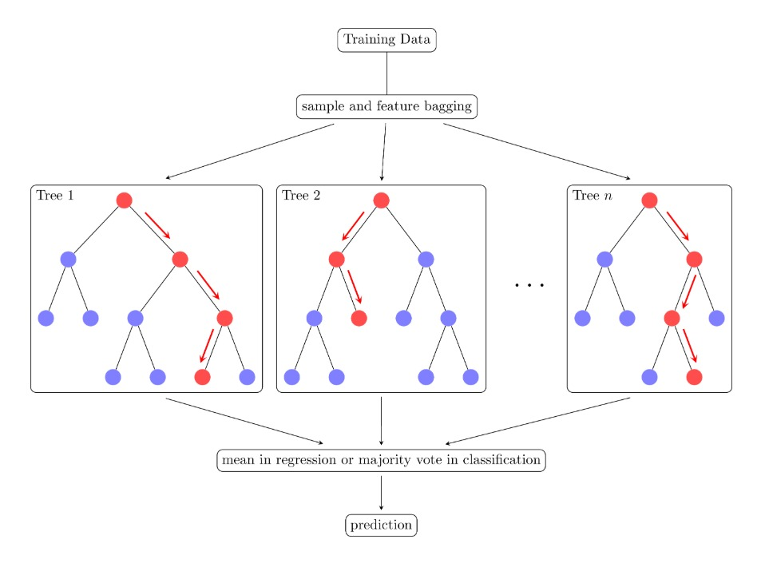
Majority vote
Figure 3.3: Random Forest Classifier

Mathematical Concepts:

Gini Impurity: This measured the probability of incorrectly classifying a randomly chosen element in a node.
Gini(t) = 1-∑_(i=1)^C▒pi2
Where:
pi is the probability of class i in the node
C is the total number of classes
Information Gain: Used to determine the best feature to split.
IG(D,A) = Entropy(D)- ∑_(v∈Values(A))▒〖|Dv|/|D|.Entropy(Dv)〗
Majority Voting:
y ̂= mode(h1(x),h2(x),...,hn(x))
Where hi(x) is the prediction from the ith tree
Random Forest Classifier is a preferred choice when working with such financial data. Its robustness, scalability and ease of implementation make it suitable for this price movement classification. Moreover, Random Forest approach reduces the variance of individual trees, leading to high predictive accuracy.

CHAPTER-4

OUTCOME & CONCLUSION

4.1 OUTCOME
The outcome of this project is to develop a machine learning based predictive model that can classify future dogecoin price movement as up or down rather than exact price, making it practical for real world decision support in crypto trading.

4.2 CONCLUSION
Dogecoin started as a fun internet joke in 2013 but now it has become a serious digital currency that millions of people new trade and invest. This project approach to help new traders and anyone trying to understand the market to predict the price might move up or down instead of trying to guess the exact price. This proposes system ensure to clean and prepare the raw dataset and with future engineering enhance the dataset with meaningful attribute that capture underlying market pattern.

REFERENCE

[1]. G. Guru Pradeep, M. Harish varan, and K. Amsavalli, "Cryptocurrency Price Prediction using Machine Learning," International Journal of Advanced Research in Computer and Communication Engineering, vol. 12, no. 4, Apr. 2023. Doi: 10.17148/IJARCCE.2023.124140.
[2]. G. Prema Arokia Mary, S. Sathyavathi, A. Dheesiga, S. Krityaa, and V. Prithiv, "Cryptocurrency Price Prediction," Department of Information Technology, Kumaraguru College of Technology, Coimbatore, India.

